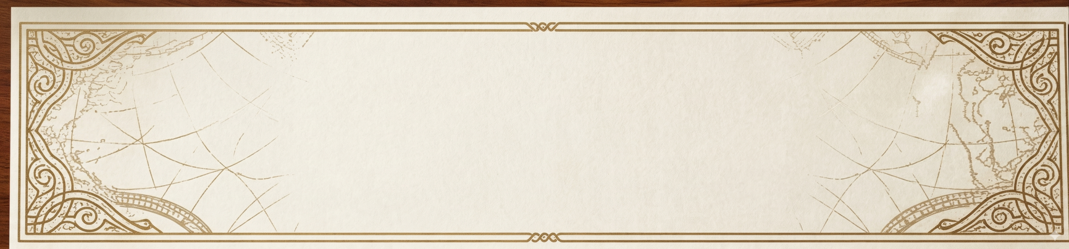

Certificate of Authenticity & Appraisal

THIS DOCUMENT CERTIFIES THAT THE FOLLOWING ORIENTAL RUG IS THE PROPERTY OF:

Mohammad Nazif Saify

3260 Duke St Alexandria VA 22314
Rug Identification
Rug Number |  | 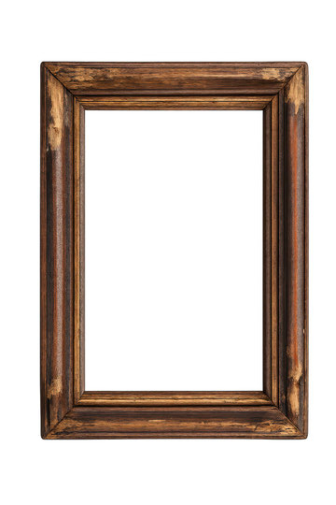
Type
Size
Composition
Origin
Condition
Estimated Retail Value | $
Date: March 22, 2026

Marco Polo Oriental Rugs
Certified Oriental Rug Appraiser

------------------------------------------------------

MARCO POLO ORIENTAL RUGS | 3260 DUKE STREET, ALEXANDRIA, VA 22314 | (703) 461-0207

